(D2.1)TEMPLATE GOOD PRACTICES (The fields with the red star are mandatory in order to upload successfully a good practice. The rest ones are optional)
GENERAL DATA
TITLE OF THE GOOD PRACTICE * | Online Library Course
NAME OF CREATOR * | Urszula Poślada
POSITION AND TASK OF THE AUTHOR * | Librarian
FURTHER DETAILS: INSTITUTION/ EMAIL/WEBSITE | Library of Maria Curie-Slodowska University  Library website: http://bg.umcs.lublin.pl/nowa/index_en.php  Online course: http://biblioteka.kampus.umcs.lublin.pl/moodle/
EDUCATIONAL LEVEL: SE/HE/AE * | AE
COUNTRY/ LANGUAGE * | Poland, Polish
KEYWORDS (tags) * | social networks, digital media, Moodle, e-book, Library course
DATE (TIME/DURATION) | 10-12.2012
DESCRIPTION
SHORT INTRODUCTION * | Aim of the course is to offer to first year students an online electronic book about university library and its resources.  At the end all students have to pass an online test (there is a pool of 80 questions in total and system is choosing 20 for each student to answer).  This project allow for:  - more interactive form of classes (electronic guide)  - train 5000 students in 4 months (by 7 teachers)  - getting used by students to university e-learning platform  - developing by students competences of self-management
TARGET GROUPS * | First year students
TYPICAL AGE RANGE
SHORT DESCRIPTION OF THE CHALLENGE FACED | The biggest challenge was the number of students who are expected to take as course and pass online test (5 000). First of all it could make problems with server. Another issue was question of students account and data for login to the platform.
TYPICAL LEARNING TIME
AIM | To deliver to students necessary knowledge about the system of university libraries, their resources and searching for information (this knowledge is needed for successful study).  To support students in passing library test.
DESCRIPTION OF THE SOLUTION/S DEVELOPED OR ADOPTED * | Students have an access to the course all the time but they are divided into groups for passing the test (there are special time slots for passing online test by students from different faculties).  Students set up their accounts by themselves. They are obliged to used their students index numbers in theirs profile data.
DIFFICULTY
TOPICS OF GOOD PRACTICES * | ICT enabled learning  Community Building  Quality and Assessment
CRITERIA (click on the appropriate boxes, please) * | Transferable Adaptability x  Innovative x Acceptability  Impact Actual  Sustainability Effectiveness x  Availability x Creativity  Accessibility x Collaborative
ACTIVITIES/IMPLEMENTATION * | On university e-learning platform library courses are set up (for each Faculty). On the platform there are special electronic materials (e-book and online guidelines) and online test are prepared. There is also a special online qestionnaire for evaluation of the course and its effectiveness (by the students).  Each faculty students have an access to the course whole project but there are special time slots for passing online test by different groups of students. Each student has to answer 20 different questions (there is a pool of 80 questions and system is choosing questions for a given student – questions and answers are mixing all the time). There is possibility to multiple attempts to pass the online test.  7 teachers are responsible for materials (resources) and test questions. After passing the test they give them credit.
STATUS
CONTRIBUTE
RESOURCES (Optional):  - Cost  - Human resources  - Infrastructures/material resources  - Other resources (please, specify) | 7 teachers and 1 instructional designer  e-learning platform – Moodle
TOOLS USED (Optional): | e-learning platform – Moodle (in frame of the course mainly tools “Book” and “Quiz” are used).
LITERATURE REVIEW (Optional): (BIBLIOGRAPHY, VIDEOS, LINKS, OTHER PROJECTS) | 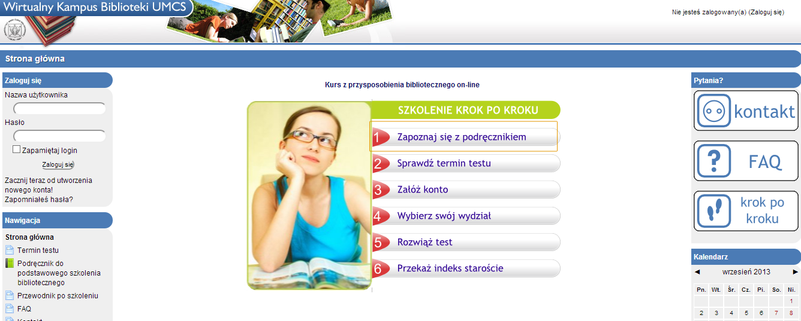http://biblioteka.kampus.umcs.lublin.pl/moodle/
FORMAT *
UPLOAD BEST PRACTICE (TEXT, PDF, ZIP) *
VIDEO (link)
IMAGE/SOUND
SIZE
LOCATION
OTHER PLATFORMS REQUIRED
COPYRIGHT *
EVALUATION
CRITERIA * | Transferable Adaptability x  Innovative x Acceptability  Impact Actual  Sustainability Effectiveness x  Availability x Creativity  Accessibility x Collaborative  Others
OVERALL RATING * | STRENGHT:  Less people are engaged in online course for 5000 students (in traditional one much more teachers had to have classes – now it is 7, earlier it was app. 40).  Organisational aspect – no more local problems for classes.  Students have access to e-book and more interactive materials all the time.  Materials are easy to update.  Online questionnaire can be used each year (after small corrections).  Students can learn at home and do test at home.  Students prefer online version of course (it is for them more attractive and accessible).  University is seen by first year students as a modern school which uses new technologies for education.  WEAKNESS:  Some students have difficulty to pass online test (they claim that it is too difficult).  There have to be a person responsible for help desk for students in case they have problems with platform or e-materials.  Students get grade/pass from librarian and it is signed in student's index. Librarians have to sign about 5000 grades in student's indexes.
COMMENTS * | Online test have multiple attempt option. Test serves as a learning tool, not only evaluation/grading tool.  Course is very easy to transfer to organisations which can use Moodle platform. If organisation have electronic student's management system it is possibility to connect Moodle database and administration database. This improvement gives opportunity to get automatically grade from Moodle course to electronic student's index.

